Paper Title

Guidelines for Technical Summary of the 26th International Display Workshops

The first letter of a noun or verb should be in capital letters and the rest in lower case letters.  
Prepositions (e.g. in, without) and conjunctions (e.g. and, or) should be in lower case letters.  
Do not use product name or trademark in the title.

Names of All Authors with Their Affiliations

Ken Ishikawa, Hideya Kumomi, Munekazu Date*, Harumi Kawamura**

Tokyo Institute of Technology, Japan, *NTT, Japan, **Salesian Polytechnic, Japan

The first letter of the first, middle or last name should be in capital letters and the rest in lower case letter.

The affiliation and author information described by the author is the author's full responsibility.

Abstract

Attach 50 words or less abstract for reviewing here. The technical summary consists of one- or two-page text in one column, with additional pages for figures/tables/photographs. It is used only for evaluation and will not be published.

Special Topics of Interest Preference

If your paper relates to Special Topic of Interest (STI), please indicate it, otherwise "None".

Topical Session/Topics of Scope Preference

Please indicate Topical Session or Topics of Scope to which the topic of your paper most belongs. If your paper relates to interdisciplinary topics, you can choose up to two topics.

For details of IDW Scopes, please refer to the IDW Call for Papers (https://www.idw.or.jp/IDW19CFP.pdf).

The final decision of STI and topics will be made by the Program Committee.

Presentation Style Preference

Your presentation preference must be indicated (Oral | Poster | Poster Only | Either). If you will not accept an oral presentation, please choose "Poster Only". The final decision will be made by the Program Committee.

Body of Technical Summary

Body of Technical Summary covers background and objectives, results, originality, impact, references, and prior publications.

*Page style and size*: One- or two-page text in one column, with additional pages for figures/tables/photographs. Technical Summary must be formatted in **A4**-**sized** pages.

*Font sets and sizes*: Use standard English font sets for the entire of your Technical Summary, for example **Times New Roman, Times, Arial and Helvetica**. Please express the unit for degree Celsius [°C] by a combination of [°] and [C] in the standard font. Also please keep the font sizes as are in this Guidelines format.

*File size*: File size should be less than 2 MB. Your network gateway may have a limitation of an uploading file size.

*Header*: Include the presenting author’s name and title of the paper on the header line in each page. Put the page number on the right side on the header line.

Submission format: Technical Summary submission via our website can be accepted in **PDF format without any security options**.

*Figures, tables, and photographs*: Place the all figures/tables/photographs **at the end of the text** to prevent layout disorder when reviewing. For reducing the file size, we recommend that the photographs in your Technical Summary are pasted in **JPEG** format.

# Background and objectives

Introduce the subject and describe the goal of your work.

# Results

Describe specific results. Illustrations to highlight your work are encouraged.

# Originality and novelty

Clearly describe what are new and/or emphasized points to claim the originality and novelty of your work.

# Impact

Discuss the significance of your work and compare your findings with previously published works.

# References

1. List references cited in this Technical Summary, which cover projects in related areas.

# Prior publications

1. The paper must be an original contribution. If you have published or presented material for similar work, explain how the present material differs from them.

Table 1 Figures/tables/photographs must be placed after the text of the Technical Summary

|  |  |  |
| --- | --- | --- |
| Sample | Value 1 | Value 2 |
| Material 1 | 54.3 | 45.6 |
| Material 2 | 48.6 | 34.2 |



Fig. 1 Title and terms on a figure

Title and other terms used in figures are better to be re-written in clear large letters. The figure captions are recommended.

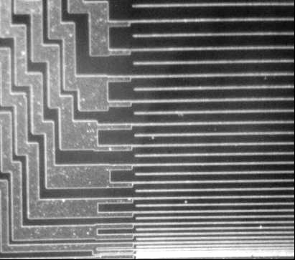

Fig. 2 File size reduction

For reducing the file size, we recommend that the photographs in your Technical Summary are pasted in JPEG format.

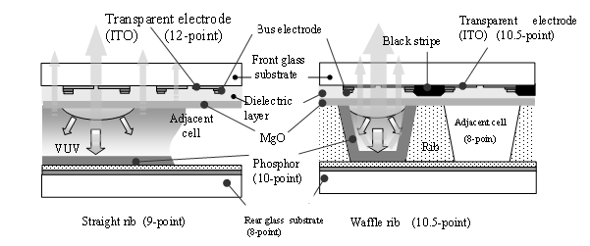

Fig. 3 Drawing with no-color figure and grouping

Too small letters or too fine lines are not acceptable. Not to use less than 8-point letters. In case of color figures, print out their black and white copies and check their legibility. Basically, black and white copies of Technical Summary are used for the evaluation with the hard prints.